JenkinsAssesment[29-08-22]

santhosh127/glogic:m1 is the image
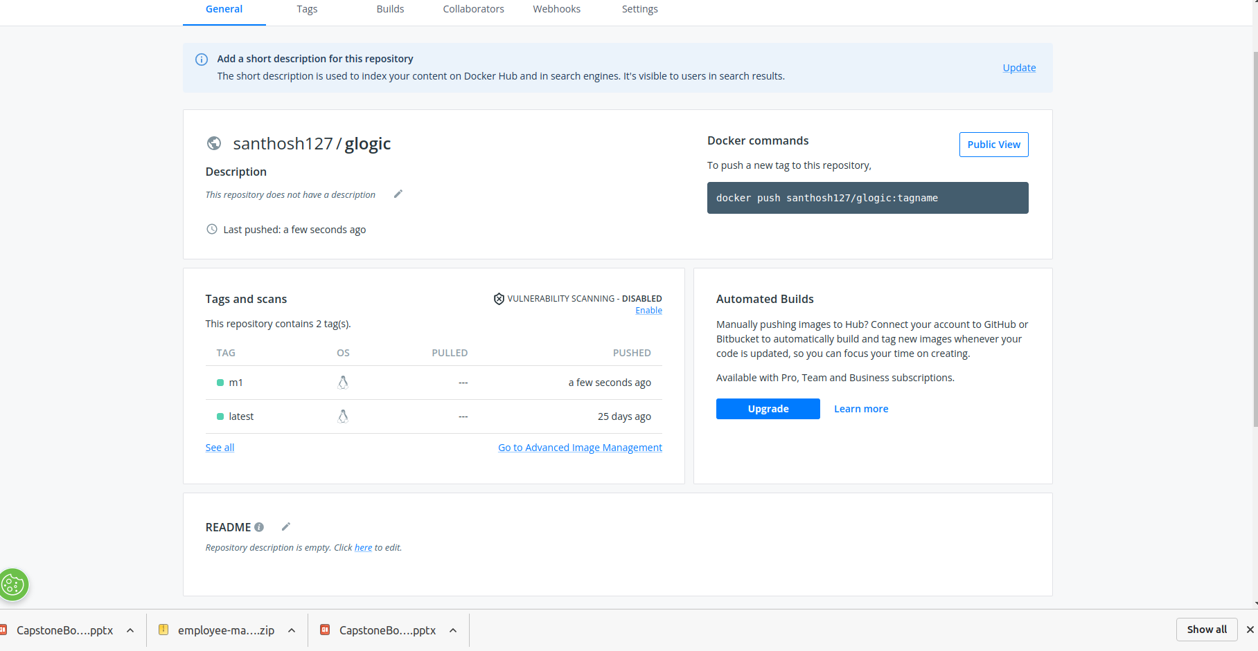
output of AddressBook
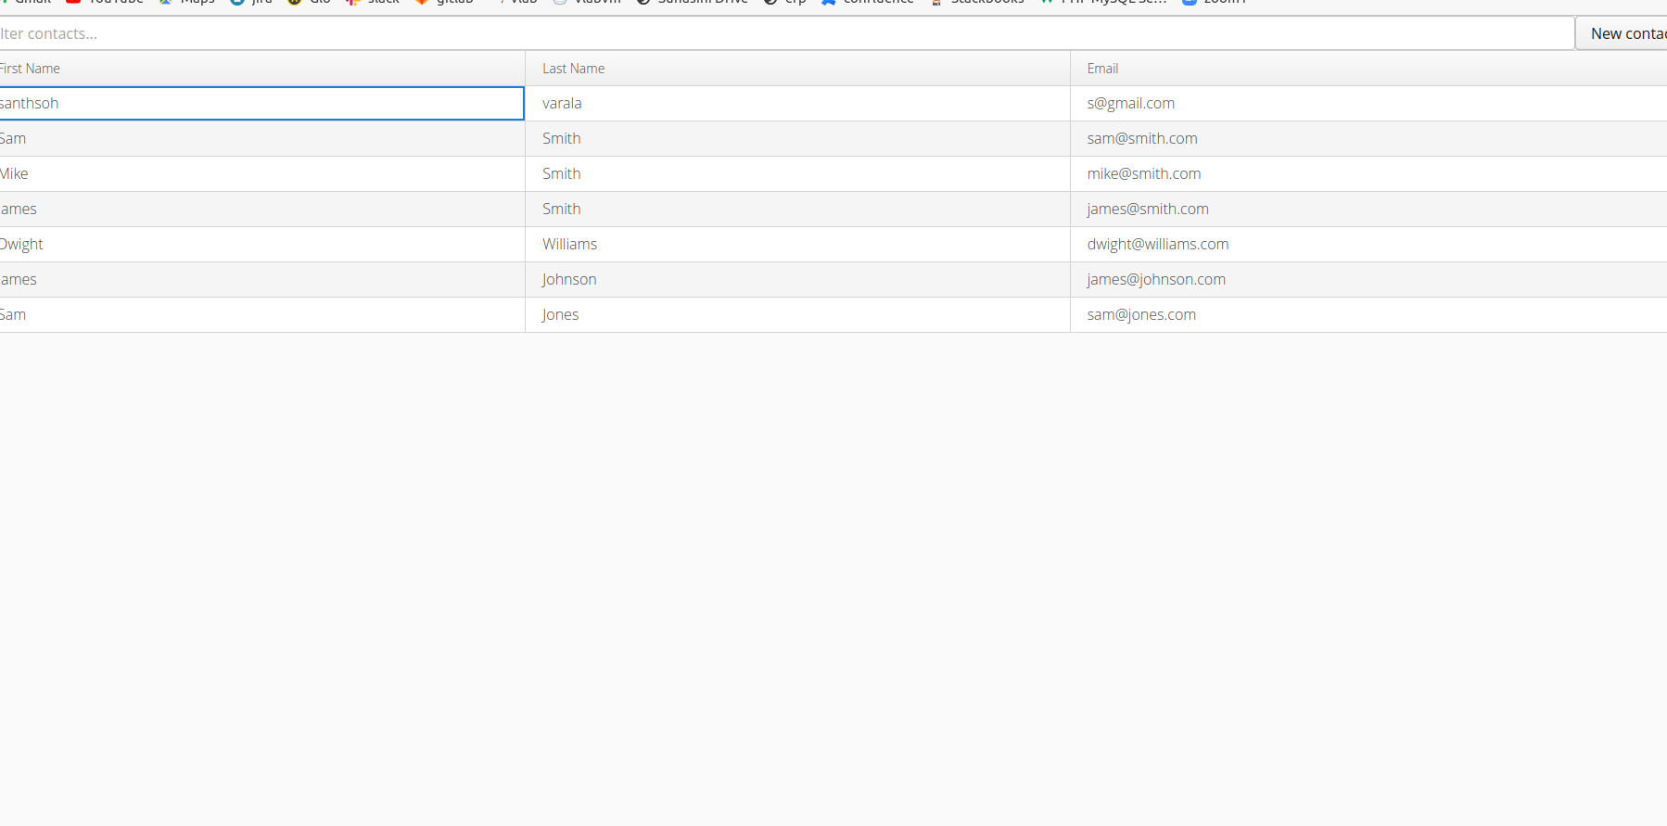

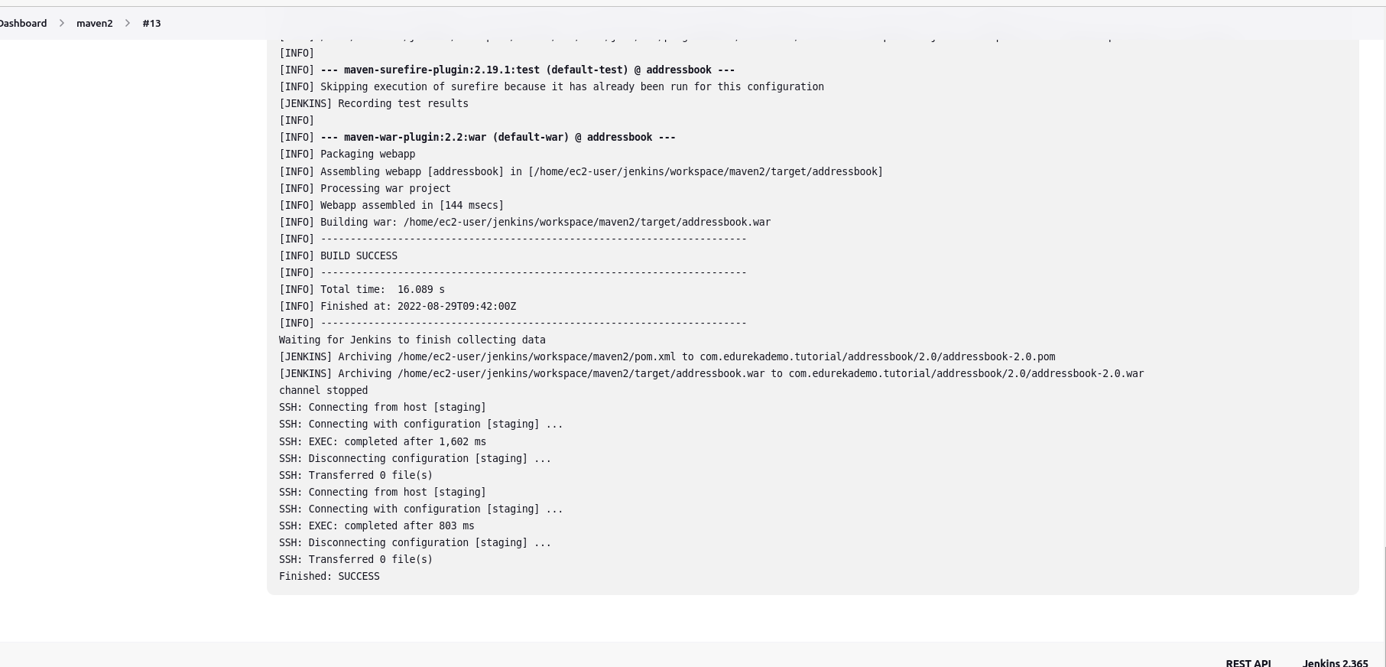
Console output that become succes

